**CSEE5590/490: Web/Mobile Programming (Spring 2019)**

**LAB ASSGINMENT 2**

**Team ID: 2**

Boyapati Ramya Class id - 4

Manda Aparna Class id -14

Yenugu Lohitha Class id - 34

YouTube Link:

**1.Basic Snake Game with Angular**

In this game, the player uses the arrow keys to move the snake around the board. There are three levels described below.

1. **Classic**: In this level, the snake moves around the maze until it finds the food and thereby grows larger. When it touches the wall, the game ends.
2. **No Wall**: This level is opposite to the classic level. When the end of the maze is reached, the snake can re-enter into the maze. When the snake collides with itself ,the game ends.
3. **Obstacle**: In this level, snake moves around the maze till it finds the food and the game ends when it touches the obstacle.

**Workflow of the Application:**

* This is the UI of the Snake game.

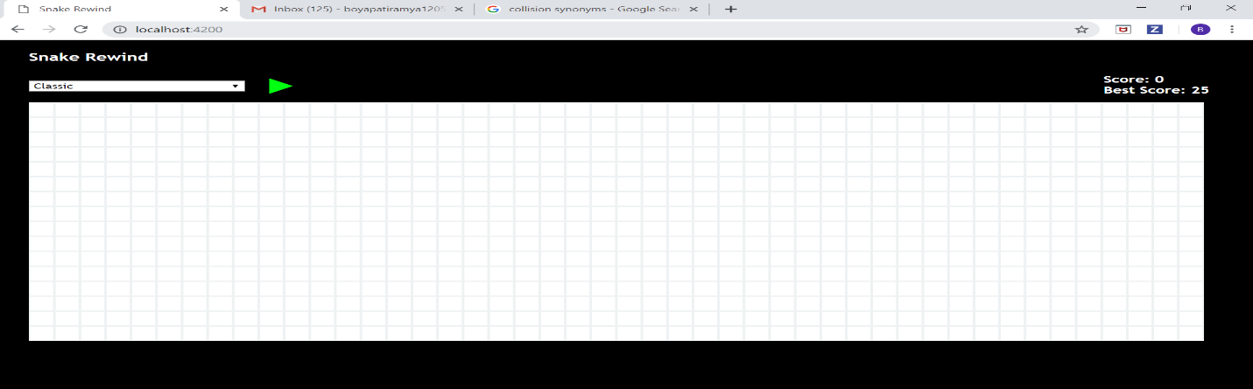

* These are the different levels in the snake game.

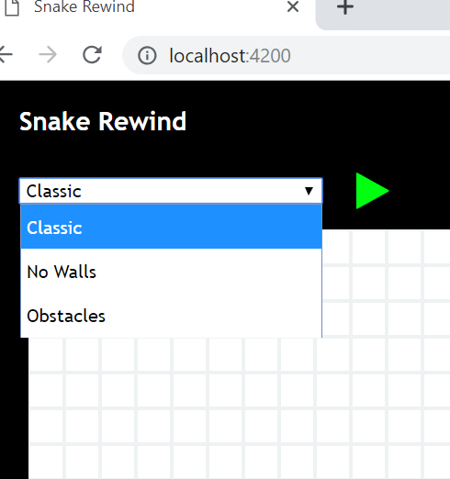

* This is how the play button looks like. When the user clicks on the play button, snake game starts and the snake starts moving around the maze. Once the game starts, play button is hidden and will be visible only after the game ends.

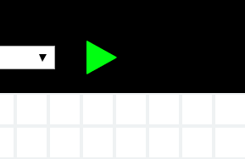

* When the snake finds the food, automatically its length is increased and the score is incremented. Along with the current score, the Best Score is also displayed on the screen.

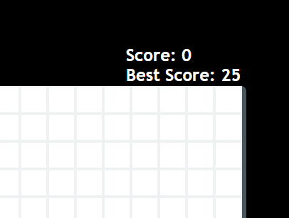

* This is how the classic level UI looks like.

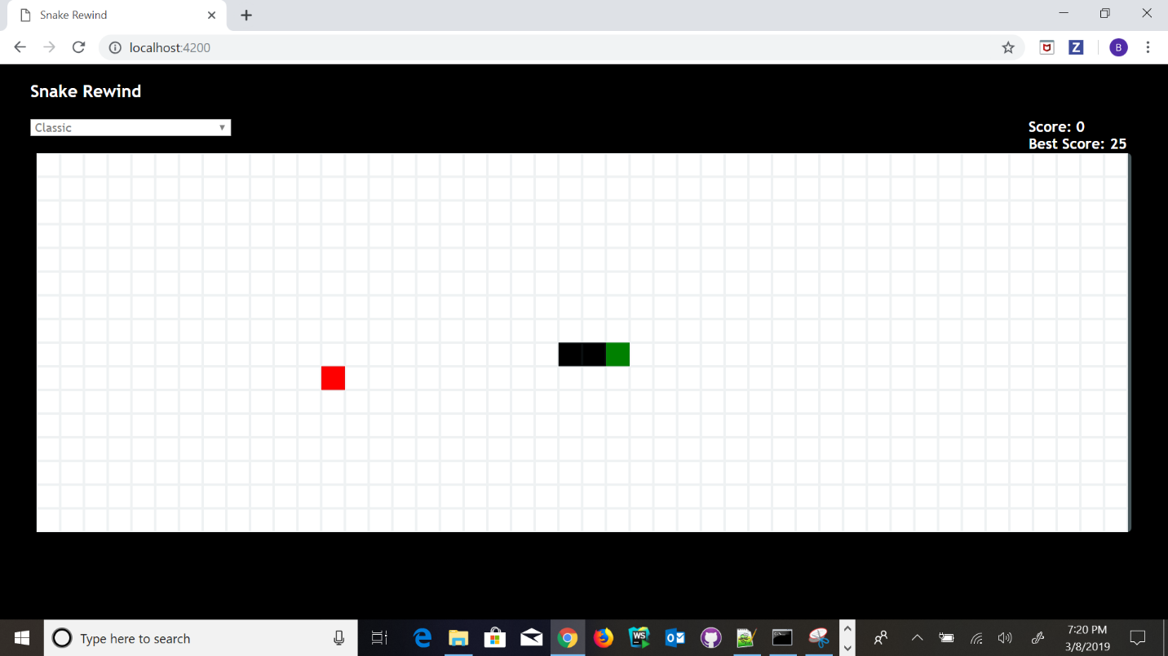

* This is the No-Wall level. In this, snake can re-enter from the other end.

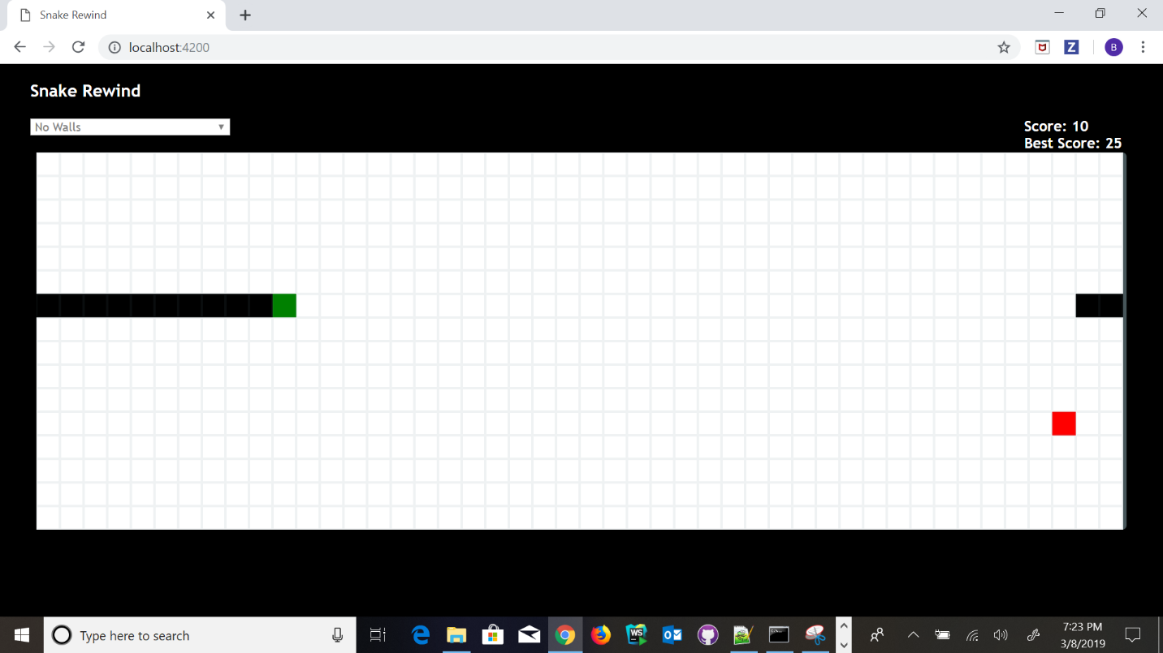

* This is the Obstacles level. In this, the obstacles are scattered around the maze, and when the snake touches it, the game stops.

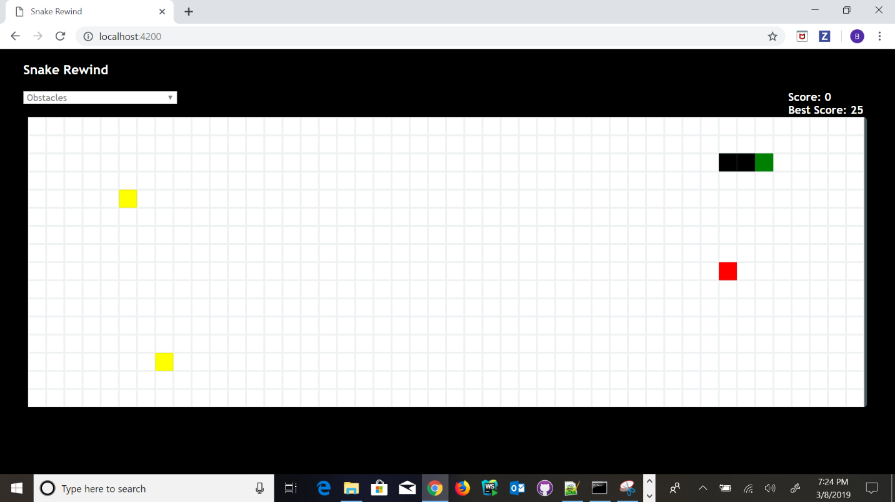

* On Game End, the following screen will be displayed .

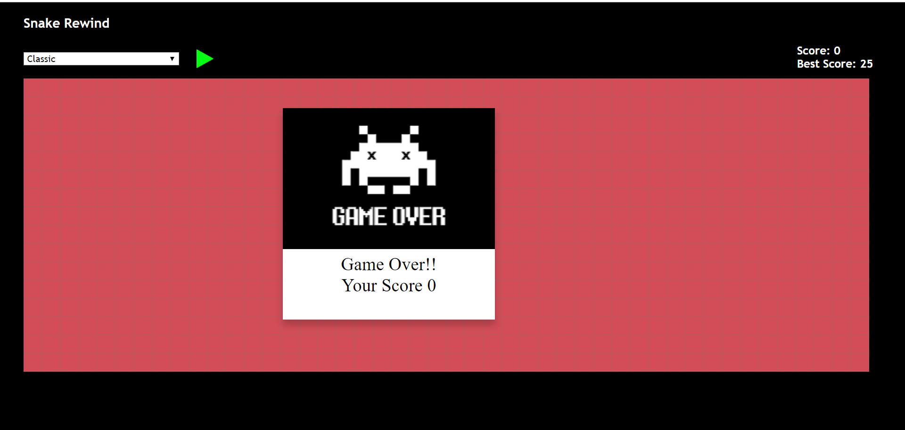

**2.Google Knowledge Graph Search API**

This is how the application looks like

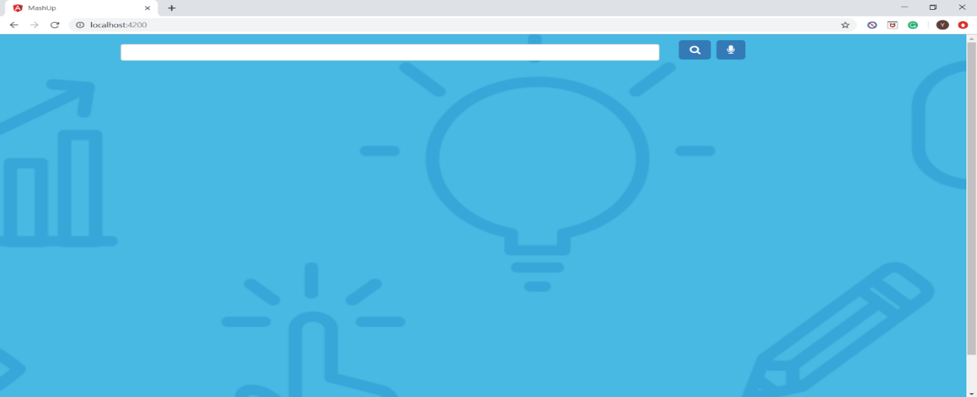

We can search for notable entities either by keying in the input field or by voice search and the results are displayed using **Google Knowledge Graph Search API**.

1. Key in the search word and click on search icon for the results.

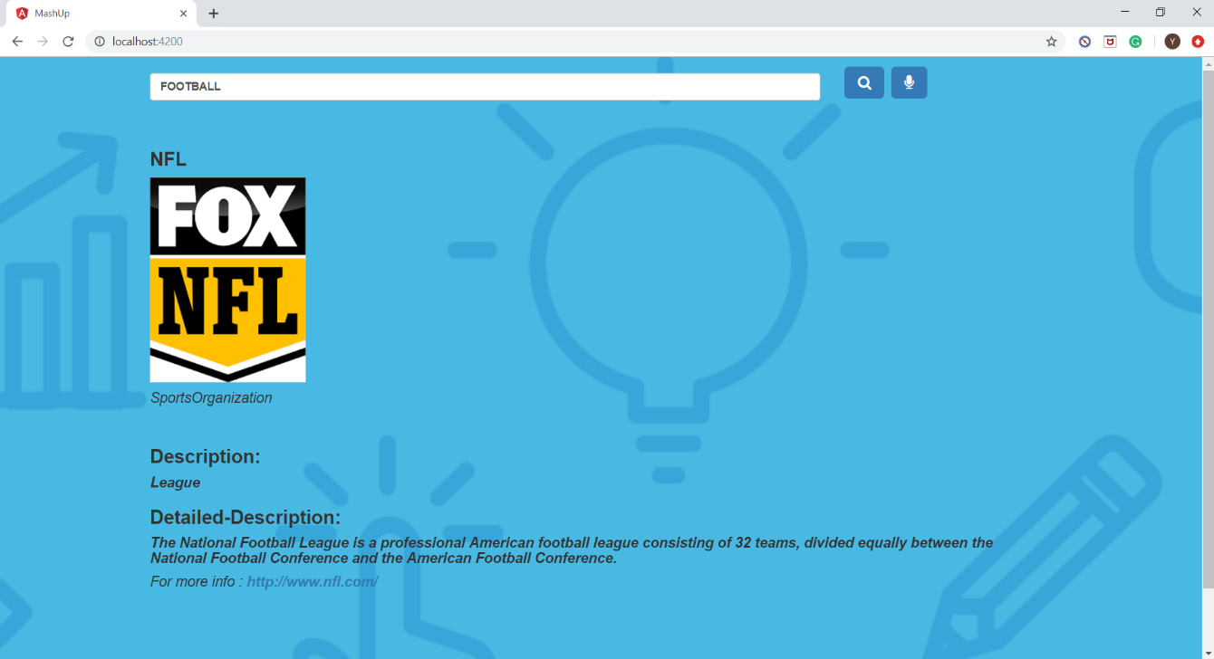

2. Click on voice recorder icon, next to search icon and speak to the computer

voice recorder in English for the results.

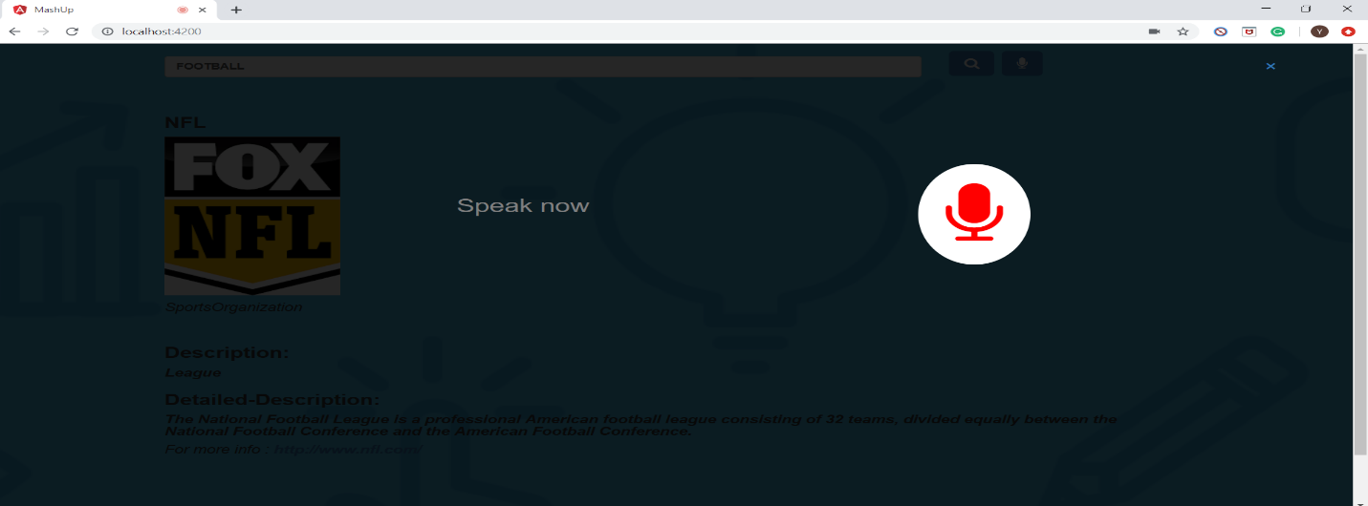

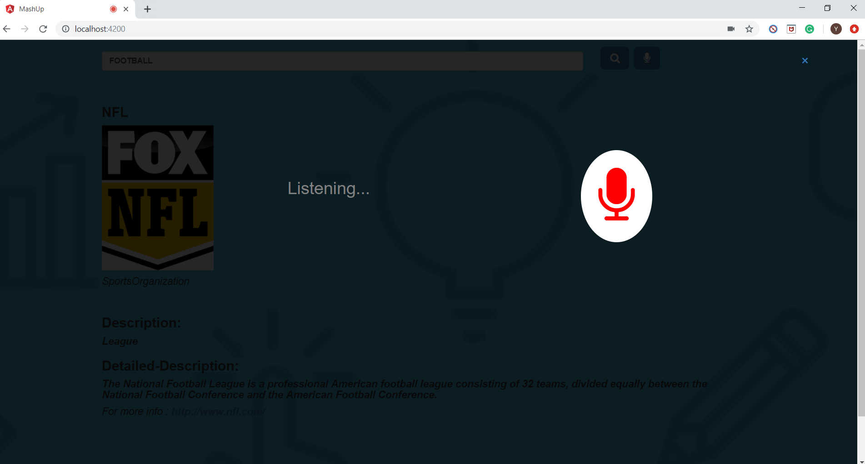

Once the service recognizes your keyword, the overlay is hidden and the results are displayed accordingly.

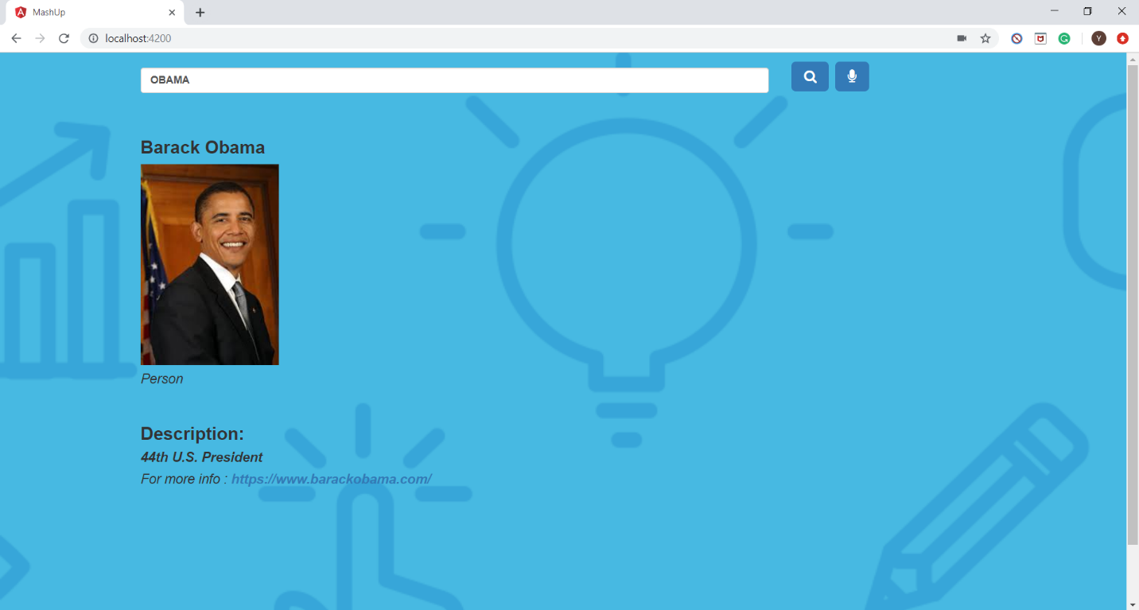

**References:**

<https://developer.mozilla.org/en-US/docs/Web/API/Web_Speech_API>

https://developer.mozilla.org/en-US/docs/Web/API/SpeechRecognition